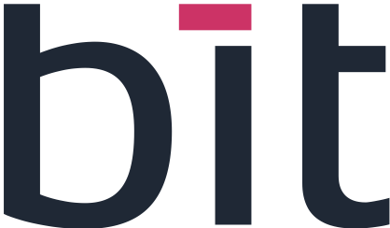 | 

INFINEON / BIT EXCELLENCE PROGRAM — 2026
WATER SUPPLY APP
Business Model Canvas

1. Customer Segments
- Farm operators
- Food manufacturers
- Organic distributors
- Juice manufacturers
- Not only B2B but also B2C
- Water Supply — farm operators are the direct users, through irrigation managed block by block. Food manufacturers benefit from water traceability and compliance for each batch.

2. Value Proposition
- Dried mango available all year with constant quality
- Traceability from the orchard block to the packet
- High-quality product
- Products delivered on time with high reliability
- Higher customer satisfaction through traceable mango
- Reliable renewable energy for the customer, with diesel/fuel generation as a backup
- Water Supply — automatic irrigation per block based on growth stage, water quality tests per tank and per batch, and a water availability forecast. It covers the orchard side of the traceability promise.

3. Channels
- National and international trade fairs
- Social media, emails and LinkedIn
- Customer marketing campaign
- Work with cooperatives
- Work with supermarkets
- Work with Infineon

4. Customer Relationships
- CRM: work on loyalty
- Use and collect customer feedback
- Reporting and dashboarding
- Supplier relationship management
- Help with setup and configuration
- Water Supply — dashboards for consumption and levels, and help to configure zones, blocks and quotas at the start.

5. Revenue Streams
- Off-season sales at a premium price thanks to storage
- Sale of the app
- Stakeholder and customer visits
- Subscription
- R&D
- Water Supply — the module is part of the app and the subscription. Visits rely on Visitor Management (live counter and safety instructions).

6. Key Resources
- Cold rooms, IoT sensors and the digital platform active
- Fresh mangoes in sufficient quantity and quality
- The development and review team
- Water Supply — a tested and documented module that helps secure enough fresh mangoes through well-managed irrigation.

7. Key Activities
- Controlled storage of fresh mangoes: sensors, FIFO, alerts (Drop Storage)
- Shipment planning
- Water Supply — irrigation planning and automation, follow-up of quotas and levels, and water quality checks per batch.

8. Key Partners
- Supermarkets
- Cooperatives
- Labs and research
- Cloud and IoT providers
- Companies in Germany
- Sonabel (grid emission factor)
- Logistics: 3PL
- Water Supply — IoT providers for the valves and the gateway.

9. Cost Structure
- Energy for cold rooms and dryers, the biggest cost item
- Fixed cost
- Variable cost
- Maintenance costs: MRO cost
- Cost of the platform
- Marketing cost

Summary in One Paragraph
In short
The business model is built around dried mango available all year with constant quality and full traceability from the orchard block to the packet. The Water Supply module supports it on the orchard side, with automatic irrigation, water quality and traceability per batch, and dashboards for the people who manage the water.

